DESIGN AND IMPLEMENTATION OF A DEATH REGISTERATION

SYSTEM,

CASE STUDY OF

MUHORORO SECTOR.

BY

VALENTINE IZABAYO

IS24221

A FINAL PROJECT REPORT SUBMITTED TO THE DEPARTMENT OF INFORMATION SYSTEMS IN PARTIAL FULFILLMENT OF THE REQUIREMENTS FOR THE AWARD OF A DIPLOMA OF INFORMATION SYSTEM OF DAVIS COLLEGE-AKILAH

JULY, 2021

**Declaration**

I, Valentine IZABAYO do hereby declare that this proposal document is my original work and has not been published and/or submitted for any other diploma or degree award to any other university or institution of higher learning before.

**Approval**

This project report has been submitted for examination with my approval as the Akilah Institute Information Systems Project Supervisor.

Vedaste NYANDWI

**Supervisor’s names**

...................................

Date

**Acknowledgements**

First and foremost, we thank God for his provision, protection and for enabling researcher to complete this project of making this report.

A vote of thanks goes to Davis College Akilah for its leadership, guidance and providence towards this work, and to all it does to care for students.

Gratitude and appreciation to all of the instructors of Davis College Akilah, my supervisor Mr. Vedaste NYANDWI, my parents, my classmates and my family members for devoting their time to develop notes and all extra efforts to make this project report.

May God bless you all!!

List of figure

Figure 1 conceptual framework of death register system 18

Figure 2 User requirement 23

Figure 3 Functional requirements 24

Figure 4 Non-functional requirement 25

Figure 5 Functional design 26

Figure 6 functional requirement 26

Figure 7 Physical design 28

Figure 8 Administrator 28

**List of figure**

Table 1 Timeline 13

**LIST OF ACRONYMS AND ABBREVIATIONS**

ID: Identity Card

ASAP: Application Assessment and Planning Package

CRVS: Civil Registration and Vital Statistics

REM: Registered Export System

HDI: Human Development Index

SDG: Sustainable Development Goals

NIST: National Institute Statistics Rwanda

Table of Contents

CHAPTER ONE: INTRODUCTION 8

1.1 Introduction 8

1.1.1 Background of the study 9

1.1.2 Problem statement 10

1.2 Objectives 11

1.2.1 General Objective 11

1.2.2 Specific objectives 11

1.3 Research questions 12

1.4 Scope 12

1.4.1 Geographical scope 12

1.4.2 Content scope 12

1.4.3 Time scope 13

1.5 Significance of the study 13

1.5.1 to the organization 13

1.5.2 to the country 13

1.5.3 to the researcher 14

1.5.4 to the future researchers 14

CHAPTER TWO: LITERATURE REVIEW 15

2. Introduction 15

2.1 Review of related literature 15

2.2 Similar systems 17

2.3 Critics of existing systems 18

2.4 Conceptual framework and models 18

CHAPTER THREE: METHODOLOGY 20

3.1 Introduction 20

3.2 Data collection methods 20

3.3. Research instruments 21

3.4. Data analysis tools 21

3.5. Development technologies 22

3.6. Limitations of the study 23

CHAPTER FOUR: SYSTEM ANALYSIS, DESIGN AND IMPLEMENTATION 24

4.0 Introduction 24

4.1 Analysis of the old system 24

4.2 Analysis of the new/improved system 24

4.3 New system requirements 24

4.3.1 User requirements 25

4.3.2 Functional requirements 25

4.3.3 Non-functional requirements 26

4.4 System Design 27

4.4.1 Logical design 29

4.4.2 Physical design 29

4.5 System implementation 31

CHAPTER FIVE: EVALUATION, CONCLUSION, AND RECOMMENDATION 32

5.1 Introduction 32

5.2 Discussion 32

5.3 Findings from the questionnaires and/or observations 33

5.4 Evaluation of the new system 34

5.5 Limitations of the study (encountered problems) 34

5.6 Conclusion 34

5.7 Recommendations 35

5.8 Further areas of the study 35

References 36

Appendices 38

Appendix 1: Project timeline 38

Appendix 2: Data collection tool for interview questions 39

QUESTIONNAIRE FOR DATA COLLECTION IN THE MUHOROR SECTOR. 40

Appendix 3: Budget 43

Appendix 4: Researcher’s Resume 44

# CHAPTER ONE: INTRODUCTION

## Introduction

A well-developed and well-functioning civil registration system facilitate the registration of all important events such as births, marriages, and deaths, and issues certificates as proof of registration. Civil registration helps governments plan more efficiently, make better use of resources and aid, and track progress toward the Sustainable Development Goals more precisely. (Unicef, for every child, 2016).

In making civil registration the ones who need that service need to go to the sector, sometimes is hard for the registrar to register all people who come to the sector and people waste their time unregistering their dead people. According to this and other different reasons people need a system that help them to make that service online.

That case study describes how people make unregister their dead people without movement, it shows how that death register system works, its significance, and the positive impact it brings within society. The main objective of that case study is to help people to unregister dead person easily and this person to perform that activity of unregistering at the right time and anytime they want, especially to the country, it helps the country to get death records in short and to make a real plan according to real population number.

Thus chapter contains the overview of that study, and it shows the related details of the death register system because people have to recognize further specifics about that study.

### Background of the study

The death record is drawn up according to the declaration of one of the relatives or spouse of the deceased, or any other person who has sufficient information on the civil status of the deceased. If a person dies in prison, the prison must declare the death to the civil registrar of the place of death. The death must be declared within fifteen days of the date of the death. (Rwanda: Information on the official death certificate (acte de décès) and the doctor's death certificate (certificat de décès) for a Rwandan citizen, including the procedure for obtaining death documents, 2013).

A Civil Registration and Vital Statistics (CRVS) program is used to register vital events at the sector level, and data from all local registration offices in the country is immediately sent to the National Institute of Statistics. However, not all industries provide CRVS entries on a regular basis. Yet not all sectors complete the CRVS submissions regularly. According to that case researcher found that researcher can create system that will help people to do that CRVS on their own, and this help national institute to get data in regularly.

### Problem statement

Penalty for late registration after 30 days for death register. The problem researcher founded when people loose someone is possible is her or his relative or parents. In this hard time is tough to her or him to remember to go to sector to unregister that dead person. Yet after the buried ones member can go to unregister that person and she found that is too late. That person will pay penalty fees. What if this system will be applied it help people to unregister dead people in shortly and easily way.

Late registration was fined according to the new law, but this is not yet enforced; in case of dispute, a capable court’s decision will be required. Any person wishing to receive a death record for someone but not having declared the person’s death within the period provided for by the law is liable to an executive reasonably determined by an executive law.

Holidays of leaders, when a leader who is responsible to record civil registration are not around, is possible some people may miss in the record of dead person. Yet is possible registrar can take off so when her or his not working is possible the people come to unregister their dead people , and they found that register are not there, and this discourage them to come back in other time. This cause the failure of record and even in right of human being.

The incorrect number of population growth. When people was not unregister the dead people, the country was getting wrong statistics in population growth. In that way country was make plan and makes wrong budget because it get erroneous number of population.

Loss of documents, and reduction of paperwork. In nowadays registration of death or records it works on in analogy system where sectors use paper or notebooks to record that registration before entering those data in a database or record of the sector. So that culture is analogous because it is possible where the recorder to skip one record or wrote the wrong record.

## Objectives

### General Objective

The main objective of that case study is to make the system that give service of unregister dead people passing through online. That study was starts with one sector as a sample and user of the system her or his data goes on in the register database. The sector was recognize that formal information and it was transfer to the country database official in the national institute of statistics Rwanda (NISR).

To explore the gap in the already existing platforms to see what they are lacking.

### Specific objectives

1. To explore the gap in the already existing platforms to see what they are missing.
2. Investigation on market requirements of newly improved system.
3. To put the new system in place, test it and make sure it works.
4. To proposal and construct a system that associate civil to registrar.

## Research questions

1. Haw can existing system be investigated in order to discover what is missing?
2. Is system fit with market requirements?
3. Haw application, testing and justification of system is have high quality?
4. What needs require to associate civil and registrar with death registration system?

## Scope

### Geographical scope

This study was been conducted at MUHORORO sector, in NGORORERO district, the WESTERN province of Rwanda country. Also, this case study was applied by people which are Rwandans and some migrant people according to what the laws say.

### Content scope

This study was investigates the journey people walk to get to the sector. The research of the system examines the delay fault and was helps people when the leader is on holiday. This system helped people to save their time and help in the improvement and that system was help the country to know enough information to the new dead people and help the country to make the correct plan and budget.

### Time scope

This study was cover three months (May 2021-July 2021)

|  |  |  |  |  |
| --- | --- | --- | --- | --- |
| Tasks | May | June | July | August |
| Proposal writing |  |  |  |  |
| Data Assembly |  |  |  |  |
| Data Analysis |  |  |  |  |
| System Design |  |  |  |  |
| System Implementation |  |  |  |  |
| Report writing |  |  |  |  |
| System Presentation |  |  |  |  |

Table 1 Timeline

#### Significance of the study

### 1.5.1 to the organization

This system study was help the people to unregister family dead members without moving to their sector. Especially to the sector that study was been started on it. It was bring more impact especially sectors have got information in easy ways and it was support in the reduction of paper usage in sectors.

The study was wakes up people who never know about significant the civil registrations and some people who are always busy and some people who are always working. Researcher mean people who never take breaks, even always have a full activity to unregister their relative who died in a short time.

### 1.5.2 to the country

Country was get implication on that study of haw unregister action moved on and this was helps the country to get sustainable development from the records of that system database. System was helps the government to implement what the real population needs according to infrastructure. If the government can build more schools according to what statistics show.

Accordingly, that study brought more information to the country of how they come up with the solutions according to the population number. Also, it can affect the millenniums’ project on future vision. Yet that case study was given assistance the sector of where that study have be applied and how it can appear in all sectors even in people outside of the country.

### 1.5.3 to the researcher

People who was make research in that study, get a chance of knowing how that system works and this was help them to give comments, and this helps in that study to take some creativity and innovation according to the feedback will gets from the different people.

That study is major for many researchers. Maybe some researchers was searching about which preference people use in that case study, others search about the statistics about those users, others searching about what the people need. This case study was helps them to get all anticipated information related to their research.

### 1.5.4 to the future researchers

Future researchers operate the findings of this study to board on a related study. However Future researchers make research according to what that study did before and this helps and encourages them to make deep research.

In that way, that study is about helping people to get full and meaningful information about a register, so the future researcher will make more research about how that case study works and how it brings impacts society.

Accordingly, future researchers was make research about that case and how that study can be evolution according to what the researcher did before. Future researchers was operate the findings of this study to board on a related study.

# CHAPTER TWO: LITERATURE REVIEW

## 2. Introduction

Literature review launch clearly on research problem and questions, suitable and opening literature. This chapter completes a summary of previous research on the death registration system and state documents of this system. Shortly that chapter is about researching and evaluating the existing literature about that system.

This chapter was afforded the literature review which is related to the project development and makes reference to the existence of the system. The sources are referred to from the book, articles, journals, and other sources from the internet.

### 2.1 Review of related literature

The register web system is a web created by JavaScript. The researcher software application aims to complete a solution for web-based civil registration action with the support of call center functionality in the Rwanda sector region. This is easy and helps the citizens to register and unregister online. The system will work like a website where you can find the different Rwanda sectors according to where you live, you can unregister your dead people.

(death registration, 2017) The website shows The National Institute of Statistics receives data from all local registration offices in the country via a CRVS web-based tool, which is used to register vital events at the sector level. However, not all sector consistently produce CRVS entries. The website showing the death registration circumstance by producing animated figures and how it is base reaching on sustainable human and economic progress.

(Rekha, 2021) That website shows that there are several advantages to registering a death. The right to be counted at both ends of the life spectrum is essential to social inclusion. Death registration and certification are frequently essential requirements for burial, remarriage, or the resolution of criminal prosecutions in the absence of insurance or inheritance.

Unfortunately, in many parts of the country, there are significant gaps in the availability and quality of this critical statistics. This poses a significant barrier to evidence-based public policy cause of death information systems, which may be used to influence health and human development strategies. However, we applaud the growing push to register all births, deaths, and stillbirths, as well as to track causes of death across the country using the only sensible method available better quality and more thorough civil registration data. (Tanish, n.d.)

(RWANDA LAUNCHES NEW INTEGRATED CIVIL REGISTRATION SYSTEM, 2021) That website is written so far on minaloc website it shows Births and deaths occurring in health facilities will be registered and certificates issued there, whilst those occurring in communities will be registered at the cell level. Previously, all civil registration had to be done at the sector level, which taxed the public with long visits and burdened civil status authorities with additional responsibilities, resulting in delays and inefficiencies.

Law requires families in Rwanda to travel to the local government sector office to unregister dead people. On the New Times websites write on this case where it make interview with different people and many say that because of the long distance to the sectors, so people are require to cover those distance and they ended up missing the deadline of fifteen days to have filed registration. According to that testimonies population recommend that death registration can done with close to residents. (Michel, 2021)

### 2.2 Similar systems

Normally in Rwanda, there are no register systems we had, but in other countries, there are online register systems but all of those don't work in registration but they work as registers on different things.

Electronic death registration system. The Virginia Electronic Death Registration System (EDRS) allows participants in the death registration process to electronically file death records with the Virginia Department of Health's Office of Vital Records, making a paperless system possible. The Virginia Vital Events and Screening Tracking System includes the EDRS (VVESTS). The VVESTS is a collection of software that includes modules for recording and recalling key events in Virginia (Electronic Death Registration System, n.d.).

The REX system (Registered Exporter System) is a system for certifying the provenance of commodities based on the premise of self-certification. The origin of items is stated by business operators themselves through so-called origin statements. An economic operator must be registered in a database by his competent authorities to make a statement of origin. The economic opportunity converted the export register. (Registered Exporter system, n.d.)

Death registration system is multi source registration system where the mortality data are collected with different centers. (Death Registration System in I.R.Iran, 2009)

### 2.3 Critics of existing systems

Well advanced in all sections due to technology or online methods, nowadays people are using those digital methods in their life especial in registrations. The principal is set in different regions and it is implemented into different categories.

So, Electronic death registration system, The REX system, and Death registration system are open website where users of those website can use it for free. They allows user to unregister dead people, by giving long registration form by filled by the user as registration.

### 2.4 Conceptual framework and models

The role of information systems and technologies in community firms’ managing and daily procedures has been widely acknowledged and assessed as positive, since launching an online presence increase country development, real number and statistics of population growth and competitiveness with international.

About the model, the entity-relationship model is part of system design that researcher used as graphical and it approaches the relationship of that specific registration system.

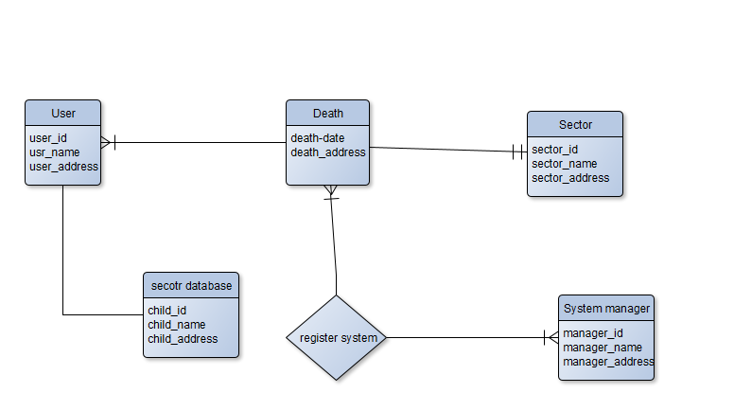

Figure 1 conceptual framework of death register system

# CHAPTER THREE: METHODOLOGY

## 3.1 Introduction

This methodology chapter researcher providing is the approach and method which have been used to develop this system. The researcher deliberated about different types of model objects in this system project and a detailed explanation of each phase in developing this project.

This part is an important technique used to manage and control or research in a project to achieve the specified objectives within a given time.

## 3.2 Data collection methods

The collection of information about that case study was worked through online research, interviewing people, and observations. At the beginning of gathering data researcher was brainstorm about the problem society faced and this give researcher to think on the possible solutions that can solve that issue and come up with idea of creating system.

Firstly researcher makes an investigation about the weakness of the existing system and why the issue is not solved after the researcher sets the unique features that help the system to perform. Researcher make research in different engines and get desirable and useful information help to know more about registration system.

During data collection methods, the researcher gathers more about the ways other system work, and researcher go in line with this data and set strong and unique system.

After the researcher makes different instrument helps to get helpful data on the system and making the clear direction of using those tools in collecting useful data. Hence researcher set an easy way to correct information related to this study.

## 3.3. Research instruments

The research instruments researcher used are surveys, questionnaires, interviews, and observations. Those are tools researcher used to get information from the users of the existing system. Moreover, the survey researcher sent to many different people, especially to people who give was unregistered their dead people, and other people researcher meet when they come from to register and unregister, that also researcher sent to the survey and they complete, after researcher get information in that study. Other instruction is did interview with people who penalized on delayed of unregister dead people, researcher ask more questions and researcher get interesting answers about it.

The same as questionnaire, the researcher uses these tools by enquiring research questions for getting descriptions about research. However, that descriptions of research questions are an instrument for demonstration data.

Observations, to see others existing systems, how they construct, what is the uniqueness of each one, and what requirement has, after to observe this researcher get something new and help the researcher to make that study differ from others study. Hence all this helps the researcher to gain useful data that help the researcher to improve that case study.

## 3.4. Data analysis tools

The Importance of data analytics in the register has generated many openings globally. The first tool is python, python is an object-oriented script language that is easy to maintain, read, write and is a free open source tool. The other one is Excel that is an analytical tool that is popular, basic, and is wide. Especially that tool was used when there is internal data of a user that must be analytics. Excel was progress in this study to help in modeling.

## 3.5. Development technologies

In this study researcher was install new technology equipment, as nowadays users want fast solutions to satisfy their registrations.

Hypertext Preprocessor (PHP) is language that imbedded in HTM. Researcher used it by managing some databases and it helps researcher to create syntax, methods and simple functions.

Cascading Style Sheets (CSS) is allow researcher to make attractive and good website. It help a researcher to show page layout, change color, and add images and font. And JavaScript helps to make structures of web pages.

The **Visual Studio Code** is a language that the researcher was used to develop the death registration system. That language is code edit redefined and improved for structure and fixing recent web and cloud applications. The visual studio code used in creation of a website that enhances user interaction with the system and it was help to make a clear and visual interface of the interface.

The internet has transformed how users communicate and engage with brands as well as with each other across the globe. Sectors have to take note as online review platforms.

In that study, we believe that our future will be mobile-driven. In that way apps are already the lens through which we involve in brands we deal with and in future our every record-keeping interaction will be driven through smartphone technology.

## 3.6. Limitations of the study

Commonly there are some documents needed to fill in the registration form. In the death register, there are needed of the cell leader’s national ID and three national IDs of different people. This means you can’t send and get confirmation messages when you didn’t complete all required fills.

When the dead people don’t have national ID that case study faces that edge. If this happens you are not allowed to fill that form when you don’t have sufficient documents. However it is child, system allow user to enter the number of birth registration.

# CHAPTER FOUR: SYSTEM ANALYSIS, DESIGN AND IMPLEMENTATION

## 4.0 Introduction

This chapter it conducted for the purpose of studying system and it describe on techniques of improves of the system also this section show process of altering system. This chapter shows determination of structure of the physical system design and ensuring if the death register system satisfy a high level of quality.

## 4.1 Analysis of the old system

Investigations on the old system is all about the weakness of the existing systems. Yet some old system it get weakness of low modern tools. According to the user of the system, their needs the latest version of the system. On the old system there are some features missed on it.

So, the old system it shows some fault like sometimes the level of service connection are low, like when user wont to register on that old system it take whole minutes of waiting that services to open.

## 4.2 Analysis of the new/improved system

The new system it come with the plot of start on the weakness of existing system and researcher goes on this and make different with the current one. That improved system it gives good services to the users and user make interaction on it.

## 4.3 New system requirements

The configuration of that death register system must have in order for hardware and software application to run smoothly and efficiently. Normally, system requirements states what the equipment is required to run the system.

### User requirements

User requirements are things the user needs the system to do. In the birth register system the user requirements are the user manager, systems and end-users, and user engineers.

Image below shows the things user are expects to from the system. This show the user information

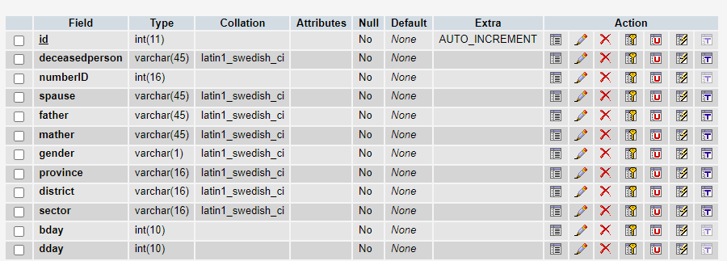

Figure 2 User requirement

### 4.3.2 Functional requirements

1. LOG in page: where the user will be able to log in to the system.
2. Service: where the available services are posted.
3. About Us: the all information of the system are stored
4. Contact us: where the administrator and users are communicated from.

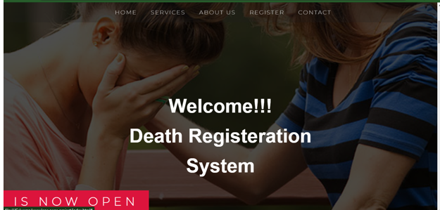

Figure 3 Functional requirements

According to this image show the difference functional requirements. The requirements of that system, system perform and it responds input accordingly. For instance on the in about user can get information of that system.

### 4.3.3 Non-functional requirements

1. security requirements
2. usability requirements
3. operational process
4. ethical requirement
5. regulatory requirements

That are some non-functional requirements of death register system. Yet they specify how the system performs in a certain functions and haw this system should behave.

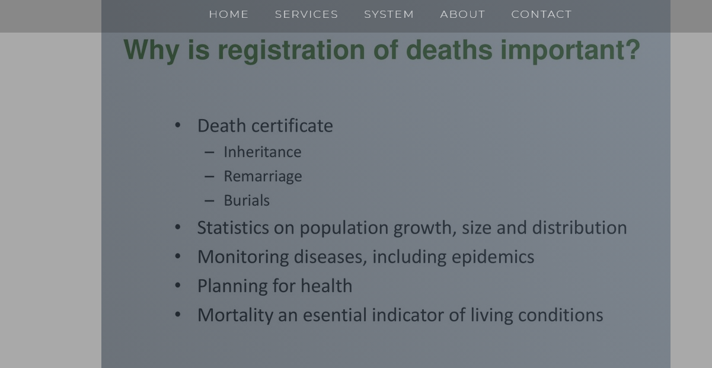

Figure 4 Non-functional requirement

According to this image show haw the many difference functions system when the system performed well it helps in different commotion.

## 4.4 System Design

This is the progression of outlining components, modules, interfaces, and data for the death register system that fulfilled requirements.

As the researcher shows the design of the system, the system has more interfaces that contain different things. The system is designed in a way the user can interact in easy ways.

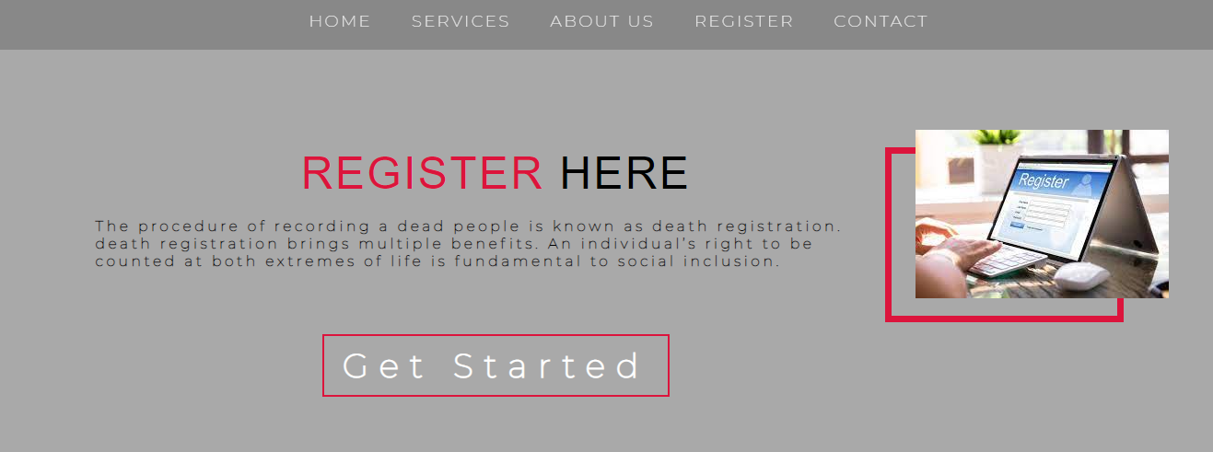

Figure 5 Functional design

System it was designed in the way user can fill the registration form and get the confirmation message. That design of form show how the user can enter her or his information on the system and the system it stored that data.

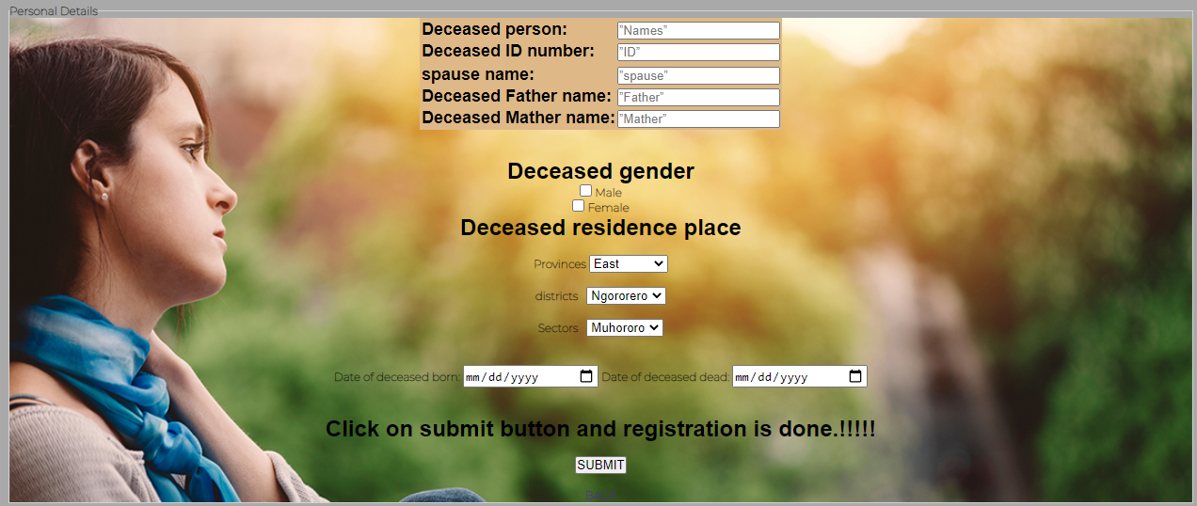

Figure 6 functional requirement

### 4.4.1 Logical design

In logical design shows what the system should look like to the user. The system was arranged data into series of logical relationships with system entities and relationships. It defines data elements in the database.

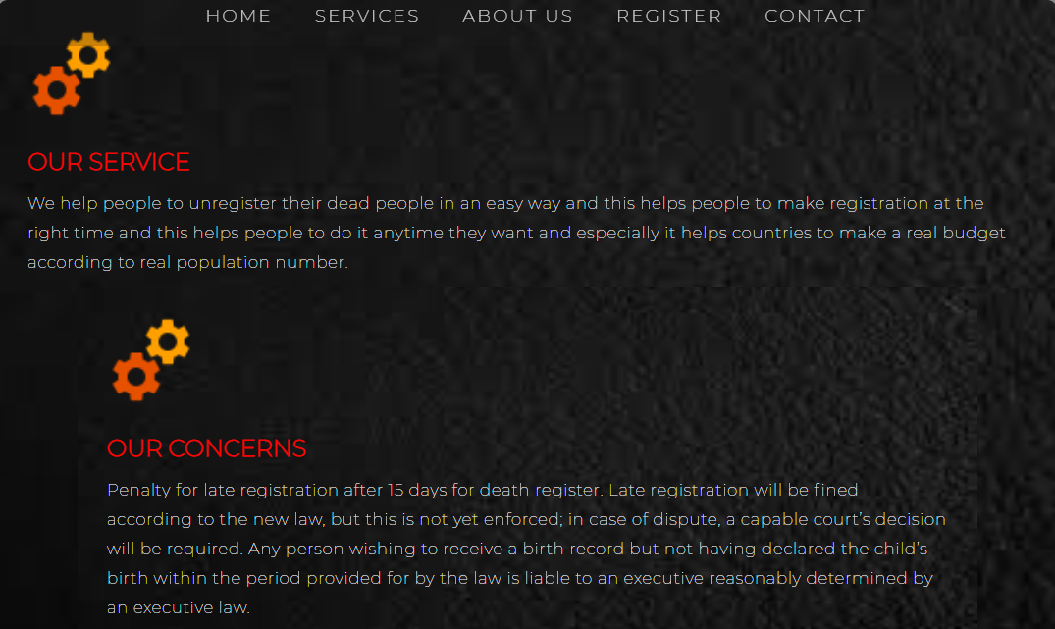

### 4.4.2 Physical design

Physical haw the system should be built. The system is built in the form of one page where users can scroll and get the new items. If user doesn’t pass with all item can click on specific items can choose on menu item according to the item user what to read or actions user want to perform.

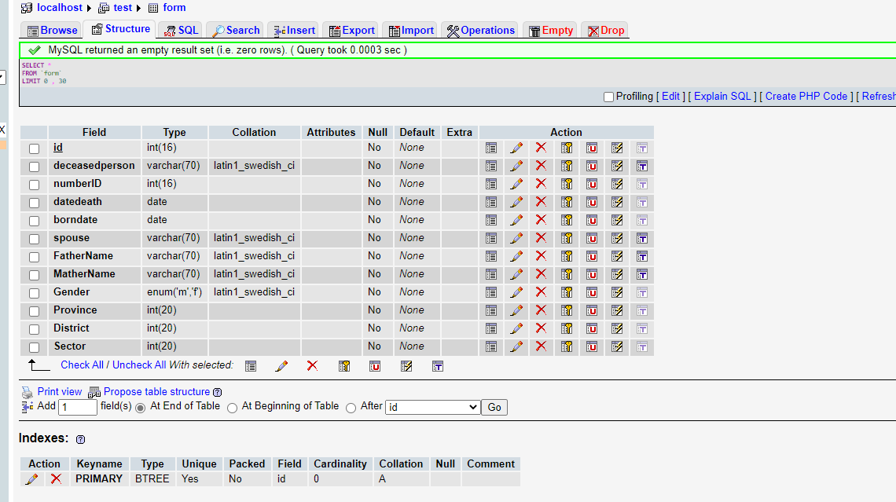

Figure 7 Physical design

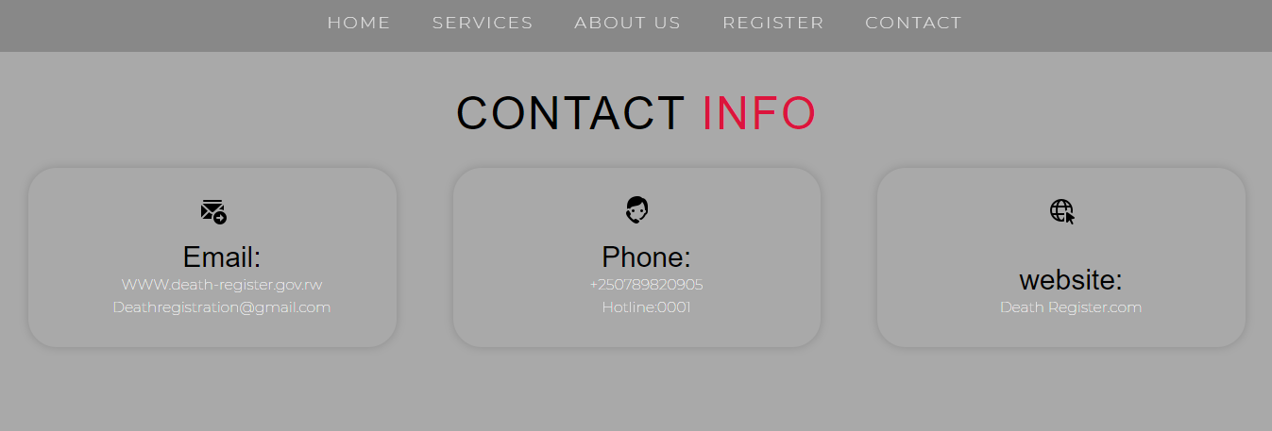

Figure 8 Administrator

The system is built in the way users can contact the administrator of a system for any issue user can meet with. In the physical system’s is constructed in dissimilar approaches.



For more information, user can get an extra sources in the addendum section.

## 4.5 System implementation

In this section death register system was defined as the ways it was built as the project of website show different interfaces and different interactions to the user who perform an activity, yet that system is built-in physical where it shows the user different borders. For instance, user can want to get contact information where the user can interact with the director or developer of the system. And also this system it was implemented according to the user needs and it matches with high-quality standard.

# CHAPTER FIVE: EVALUATION, CONCLUSION, AND RECOMMENDATION

## Introduction

The succeeding chapter concludes this report. A summary of the research is presented, and the findings of the study are discussed and interpreted. The implication of this research in the instant of unregister dead people is inspected.

Recommendations for further researcher end the chapter.

The scope of the succeeding conclusions is limited to the framework and historical features of the death register system. Hence, functional to the other conditions, these conclusions might produce appropriate expectations. Still, these conclusions are relevant to the process of evolution in progressive development projects.

## Discussion

This study experiential the process of evolution in progressive development projects.

A powerful and well-functioning civil recording system simplifies the recording of all important events such as births, marriages, and deaths. There are some problems accused to the registration like a penalty for late registration after 30 days for death register, in that way late registration was fined according to the new law, but this is not yet enforced; in case of dispute, a capable court’s decision will be required, and loss of documents, and reduction of paperwork.

Those are some cases that the death register system has come to solve, it objective is to help people unregister dead person easily and this person to perform that activity of unregistering at the right time and anytime they want, especially to the country, it helps the country to get death records in short and to make a real plan according to real population number.

On the research, questions researcher ask more queries but the interesting ones are the weakness and strengths of an existing system, Haw system brings an impact on society, and how the system has overcome the challenges. In the accompaniments approach, there are a technique used to manage the research in this project for purpose of achieving the specific goals.

## Findings from the questionnaires and/or observations

As progressive expansions, the research instruments researcher used are surveys, questionnaires, interviews, and observations. Those are tools that helped to get information. From all this findings researcher found that the people need the system that gives service of unregistering dead people used online platform. Hence, for observation to another existing system, the researcher found the figures of how existing systems constructed, the uniqueness of each one, and its requirements.

Thus, on the questions, the findings show when the system was implemented it help people to serve their time and make registration in easy ways and country get implication on the system services. Yet it gets also haw system it can overcome any challenges. Especially for findings is innovations system can add rather than the existing systems for purpose of bringing unique.

## Evaluation of the new system

The system performs well-referred to the teste of the researcher got in different findings. In the new system, the change comes in the way people unregister their dead people, this service is easy to be performed.

## Limitations of the study (encountered problems)

Because of the following validity issues, the researcher demanded an allowable edge of fault. Measures were also suggested to lessen, if not remove, challenges to the validity of the study's conclusions:

Due to the COVID-19 pandemic is hard for researcher to get enough information because is hard to reach on different respondents, however researcher tried to her best by spending more time with research and researcher asked support using online methods.

Lack of financial resources, such as transportation fees, printing, and communication, among other things, might stymie productive research. In that challenge researcher got aid from parents.

## Conclusion

To perform civil registration population takes a long journey and much time does it. Sometimes is hard for the registrar and it is not going well. The researcher makes a system that helps people to perform that civil registration but the researcher focus on unregister dead people. Thus, the system brings more impact in society and development plan because on it government get death records and starts to plan according to the population number. As a result of that system, it helps people to get a form where users can unregister dead people and after this system started many people are using it.

## Recommendations

When registration is not happening might lead to drawback fees for late registration, wrong statistics for the country, and lack of records for civil and deceased people. Consequently, making civil registration the ones who need that service needs to go to the sector, sometimes is hard for the registrar to register all people who come to the sector and people it takes long to unregistering deceased people.

The death register system has come to solve the issue of unregistering deceased people, on it, the user might unregister dead people on the online platform. Systems bring more significance in society and they help the country to get death records easily.

The researcher designed this system with a special emphasis on bold color to appeal to the viewer’s devotion to the population's imagination and to use the death register system.

## Further areas of the study

Extra areas of the study, on the researcher findings, found that there were some limitations like the scope of the study. So researcher suggests future research to address that limitation in that study for purpose of enlarging the scope of that case study.

# References

*ASAP*. (2020, jul 28). Retrieved from Software Suggest: https://www.softwaresuggest.com/us/palnetreg#user-reviews

*death registration*. (2017, Nov). Retrieved from UNICEF global : https://data.unicef.org/crvs/rwanda/

*Death Registration System in I.R.Iran*. (2009, jan). Retrieved from Knowledge base: https://unstats.un.org/unsd/vitalstatkb/KnowledgebaseArticle50546.aspx

*Electronic Death Registration System*. (n.d.). Retrieved from Virginia health department: https://www.vdh.virginia.gov/vital-records/electronic-death-registration-system/

*hostevent*. (n.d.). Retrieved from Software suggest: https://www.softwaresuggest.com/us/palnetreg#user-reviews

*Marriage Registration System*. (n.d.). Retrieved from CSM breaking though barriers: https://www.csm.co.in/offering/marriage-registration-system/

Michel. (2021, March 02). *How efficient is Rwanda’s death registration system?* Retrieved from The New Times: https://www.newtimes.co.rw/news/how-efficient-rwandas-death-registration-system

*Microsoft Excel*. (2021, April 13). Retrieved from Wkipedia: https://en.m.wikipedia.org/wiki/Microsoft_Excel

*PlanetReg*. (n.d.). Retrieved from software suggesst: https://www.softwaresuggest.com/us/palnetreg#user-reviews

*Registered Exporter system*. (n.d.). Retrieved from An official website of the European Union: https://ec.europa.eu/taxation_customs/business/calculation-customs-duties/rules-origin/general-aspects-preferential-origin/arrangements-list/generalised-system-preferences/the_register_exporter_system_en

Rekha. (2021). *Importance of Birth, Death & Still Birth Registration*. Retrieved from Smart academy: https://plan-international.org/early-childhood/birth-registration

*RWANDA LAUNCHES NEW INTEGRATED CIVIL REGISTRATION SYSTEM*. (2021). Retrieved from Updates: https://www.minaloc.gov.rw/news-detail/rwanda-launches-new-integrated-civil-registration-system

*Rwanda: Information on the official death certificate (acte de décès) and the doctor's death certificate (certificat de décès) for a Rwandan citizen, including the procedure for obtaining death documents*. (2013, june 21). Retrieved from refworld: https://www.refworld.org/docid/52791f4a4.html

Tanish. (n.d.). *Benefits of birth and death registration for Nation*. Retrieved from healthcare: https://www.smart-academy.in/blog/importance-of-birth-death-still-birth-registration/

*Unicef, for every child*. (2016, nov 18). Retrieved from Monitoring the situation of children and women: https://data.unicef.org/crvs/rwanda/

Weinsterin, J. (2020, sep 12). *Python resources*. Retrieved from Career Karma: https://careerkarma.com/blog/what-python-is-used-for/

*what is Irembo*. (n.d.). Retrieved from Help: https://rdb.irembo.gov.rw/rolportal/faq

# Appendices

## Appendix 1: Project timeline

|  |  |  |  |  |
| --- | --- | --- | --- | --- |
| Tasks | May | June | July | August |
| Proposal writing |  |  |  |  |
| Data Assembly |  |  |  |  |
| Data Analysis |  |  |  |  |
| System Design |  |  |  |  |
| System Implementation |  |  |  |  |
| Report writing |  |  |  |  |
| System Presentation |  |  |  |  |

## Appendix 2: Data collection tool for interview questions

Valentine IZABAYO

Davis College Akilah

July, 2021

Dear respondent**,**

**RE: GATHERING OF INVESTIGATION DATA**

I'm a Davis College Akilah scholar pursuing a Diploma Program in Information Systems. I'm conducting research to fulfil the requirements for my diploma. A record management to improve service delivery to Rwanda's unregistered dead, Muhororo Sector was the chosen sector to conduct the research.

I respectfully request that you aid me in gathering data by answering to the questions.

Your help will be greatly valued.

Yours sincerely,

Valentine IZABAYO

Davis College Akilah Department of Information Systems

Email: [vizabayo221@daviscollege.com](mailto:vizabayo221@daviscollege.com)

Tel: +250782382260

# QUESTIONNAIRE FOR DATA COLLECTION IN THE MUHOROR SECTOR.

Instructions for filling out the survey please mark the necessary boxes. Fill in the blanks with your answers to the questions. In the questionnaire, do not include your name. I'd appreciate it if you could complete the questionnaire and return it to me within the deadline.

**PART1**: **Respondent**

|  |  |
| --- | --- |
| Gender |  |
| Age |  |
| Job title |  |

**PART2**: **Examination of the current system**

**Q1. There are ways sharing information with the civil?**

Yes

No

I’m not sure

**Q2. If yes which ways do you use to share information?**

* 1. Meeting
  2. Assembly
  3. Training
  4. Other(specify)………………………………………………………………………………………………………………………………………………………………………………………………………………………………………………………………

**Q3. Which type of system does registrar use?**

Traditional system

Online system

**Q4. Almost how long does it take a registrar to register one civil?**

Less than 3hours

b. Between 5 hours and 15 hours

**Q5. How long the journey civil walk to reach on sector office?**

Less than 1.5km

Between 2 and 4km

More than 4km

**Q5. Does sector have a website or mobile app that they use?**

Yes

No

I’m not sure

**If yes which information does it provide?**

………………………………………………………………………………………………………

………………………………………………………………………………………………………

………………………………………………………………………………………………………

………………………………………………………………………………………………………

……………………………………………………….

**PART 3**: **Examination of the new improved system**

**Q6. Do you think a death registration system is needed?**

Yes

No

I’m not sure

**If yes what could it contain to satisfy the civil?**

………………………………………………………………………………………………………

………………………………………………………………………………………………………

………………………………………………………………………………………………………

………………………………………………………………………………………………………

……………………………………………………….

**Q7. What should be the qualities and strengths of this new system?**

………………………………………………………………………………………………………

………………………………………………………………………………………………………

………………………………………………………………………………………………………

………………………………………………………………………………………………………

……………………………………………………….

Q8 **Mention tasks that system could perform and haw it perform it?**

1.……………………………………………………………………………………………………

2.……………………………………………………………………………………………………

3.……………………………………………………………………………………………………

4.……………………………………………………………………………………………………

**Q9. Mention things the new system cannot perform?**

1.……………………………………………………………………………………………………

2.……………………………………………………………………………………………………

3.……………………………………………………………………………………………………

4.……………………………………………………………………………………………………

Thank you for taking the time to fill out this assessment.

God's blessings on you!!

## Appendix 3: Budget

|  |  |  |  |
| --- | --- | --- | --- |
| **Items** | **Quantity** | **Cost per unit** | **Total price** |
| Internet Bundles | 8 | 1000 | 8000 |
| Transport | 3 | 2000 | 6000 |
| Airtime | 5 | 200 | 1000 |
| Papers | 70 | 50 | 3500 |
| Pen | 1 | 250 | 250 |
| Flash Disk | 1 | 6000 | 6000 |
| **Total** |  |  | **24, 750 Rwf** |

## Appendix 4: Researcher’s Resume

Valentine IZABAYO

Kigali, Rwanda

Vizabayo221@daviscollege.com

+250782382260

**Personal Statement**

A persuaded, useful and capable Computing graduate looking for a job in an IT position which will use the proficient and specialized abilities created through past work experiences in this field.

**Education**

**2019 – 2021** Diploma of Information System Davis College Akilah

**Grade achieved: Diploma**

**2015-2018** College ADEC Ruhanga

AA diploma in Mathematics, Chemistry and Biology

**2012-2014 G.S.Kigombe**

O’level

**2006-2011 Ecole primary Muhororo**

Primary School

**Skills**

**Technical:**

Computer skills.

Leadership skills.

Public speaking skills.

Programming skills.

**Language:**

English – Fluent

French - Advanced

Kinyarwanda - Fluent

**Hobbies and Interests**

Reading Novels

Singing

Travelling

**Awards**

2020 I got certificates from Cisco in IT essential.

2021 I got certificates from Cisco in introduction to networking.

2021 I got certificates from Cisco in Routing and Switching.

**Referees**

**Mr. Justin TEGEREZA**

The School director, College ADEC Ruhanga

**Email**: justinteg@yahoo.fr

**Phone Number**: (+25)0 788866720

**Mr. NYANDWI Vedaste**

INS Instructor at Davis College Akilah

**Email**: [nyandwivedaste@daviscollege.com](mailto:nyandwivedaste@daviscollege.com)

**Phone Number**: (+25)0 784359200